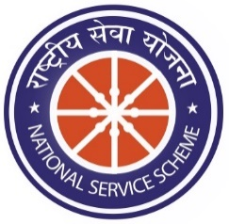
National Service Scheme
SKU College of Pharmaceutical Sciences NSS Unit
Sri Krishnadevaraya University, Ananthapuramu.

GENERAL ACTIVITIES REPORT

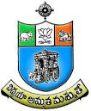

Submitted By
NSS Unit
SKU College of Pharmaceutical Sciences
Sri Krishnadevaraya University, Ananthapuramu-515 003

K. Varalakshmi Devi
Programme Officer

March, 2019

DISTRICT YOUTH PARLIAMENT FESTIVAL – 2019 ::
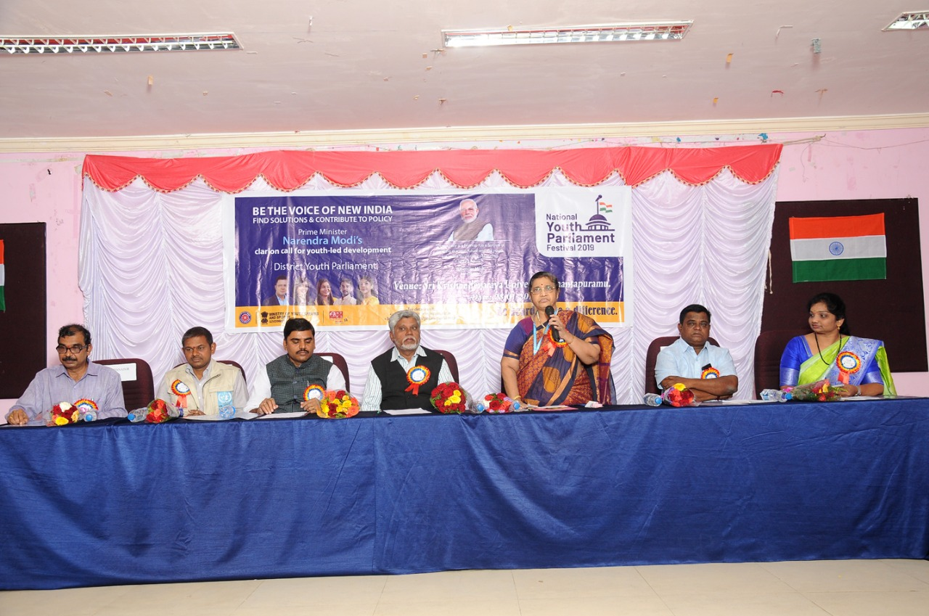

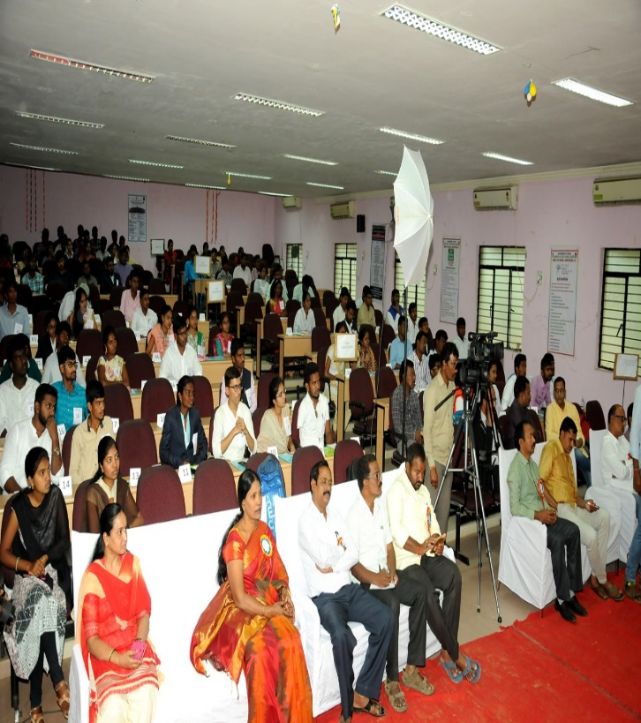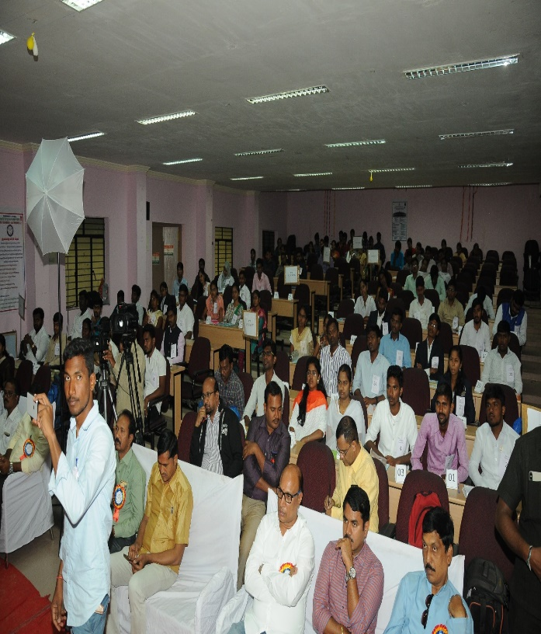

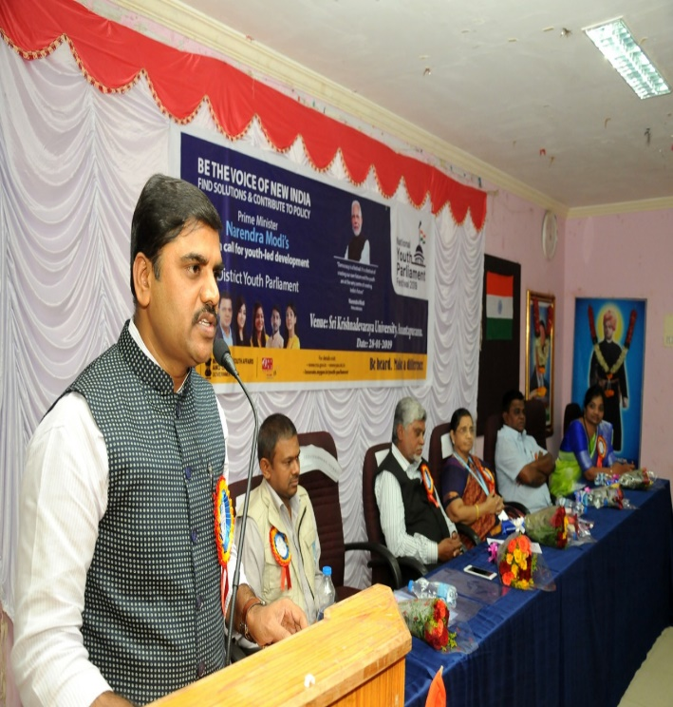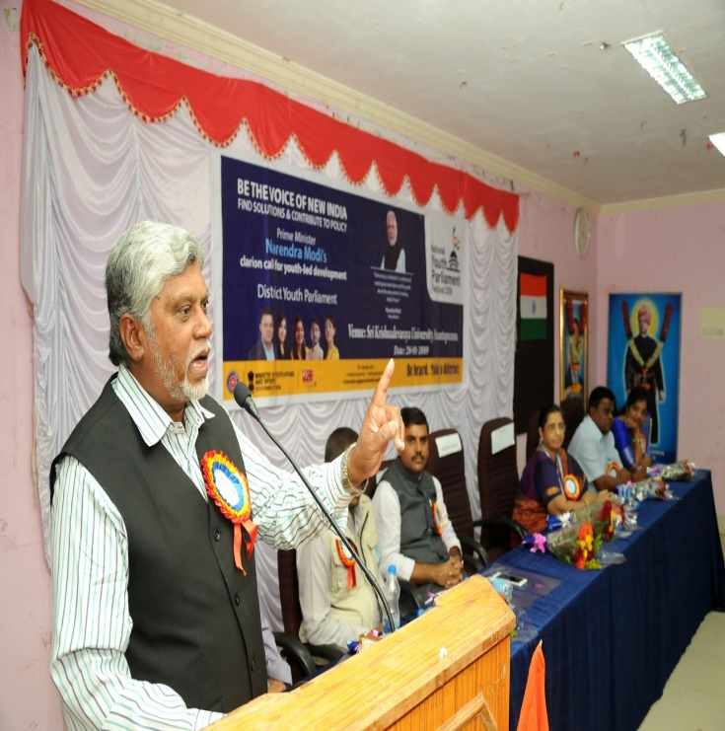

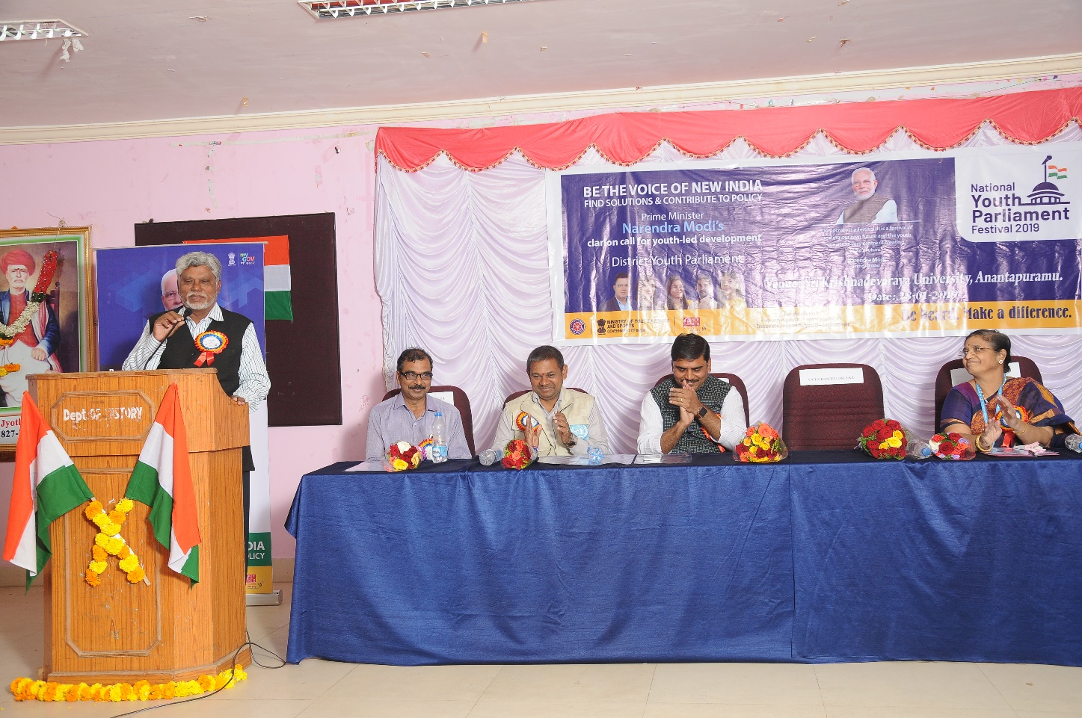

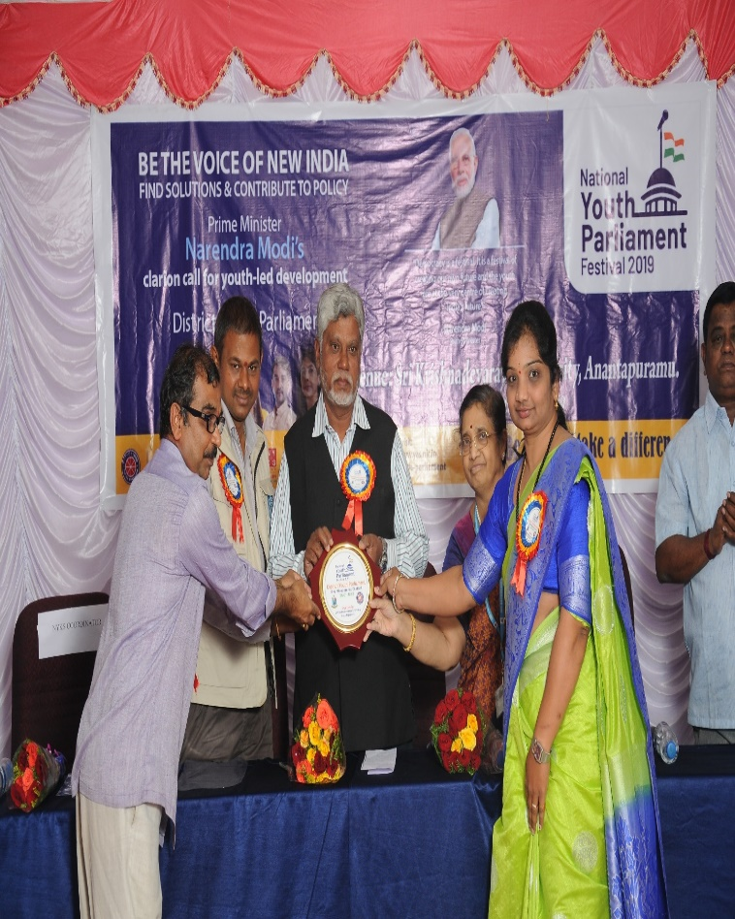
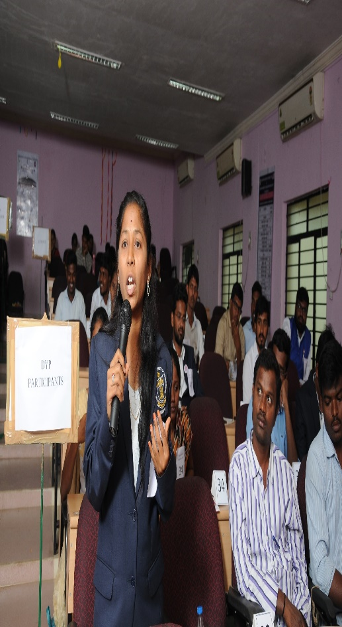

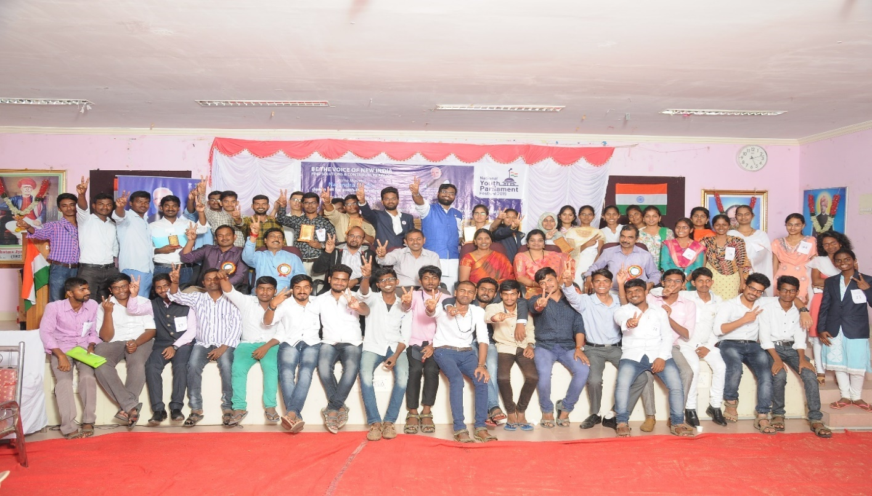

SWACCH BHARATH CAMP

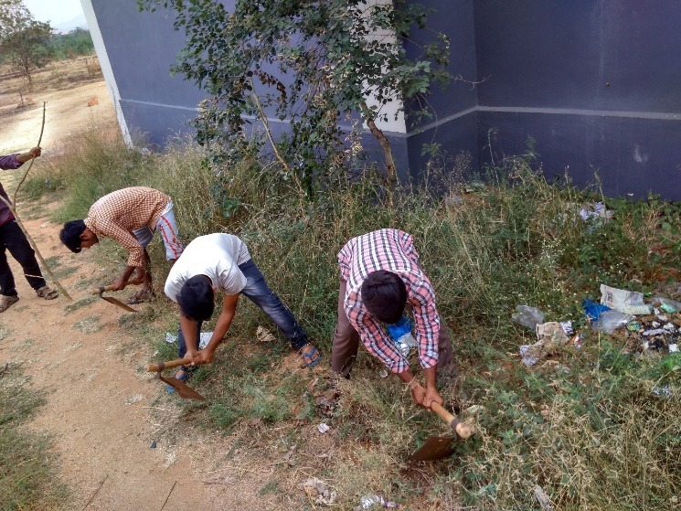
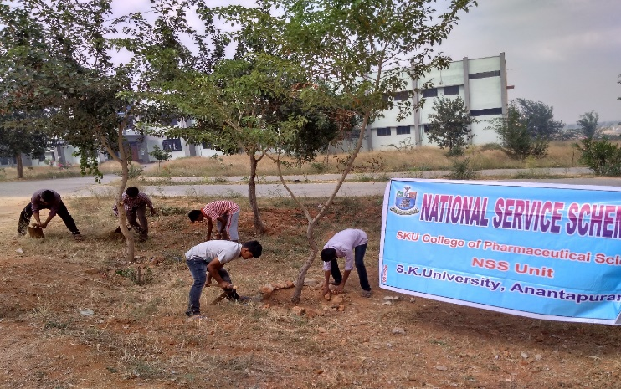

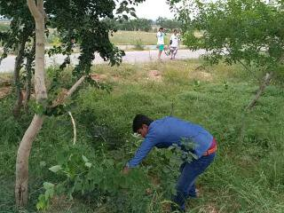

AIDS DAY CELEBRATIONS:
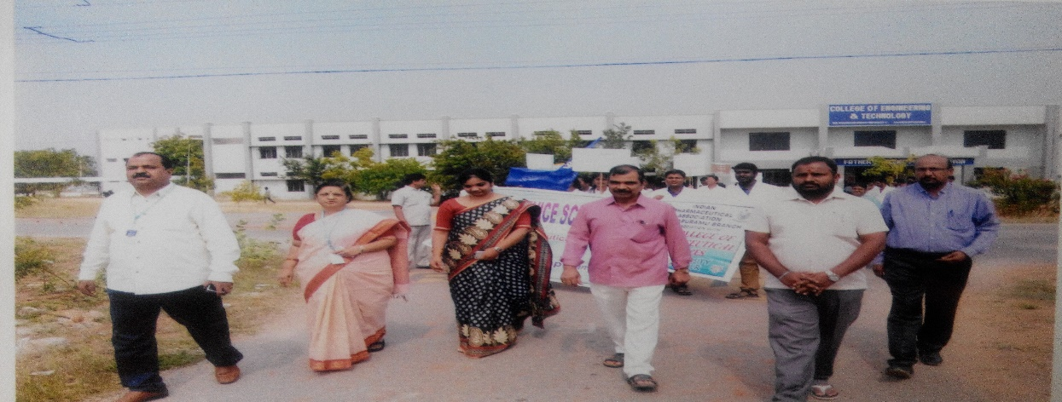

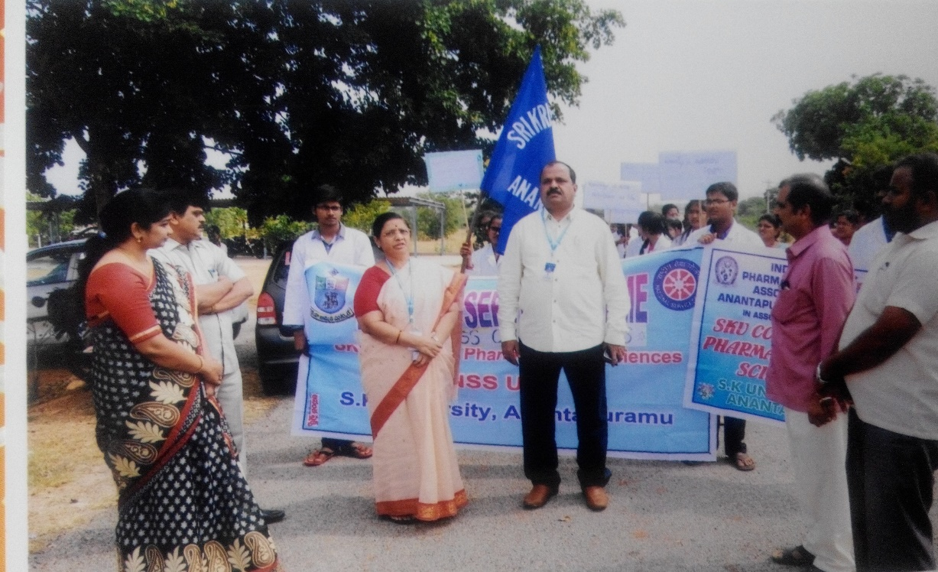

YOGA DAY CELEBRATIONS
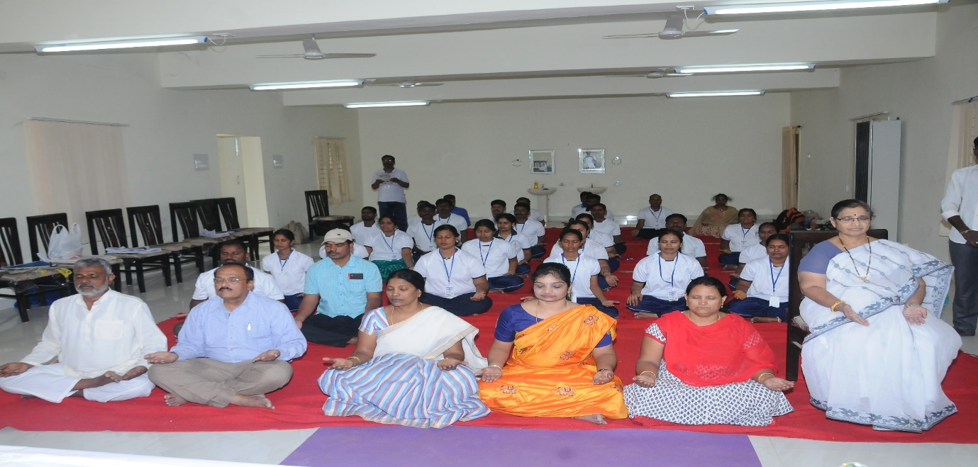

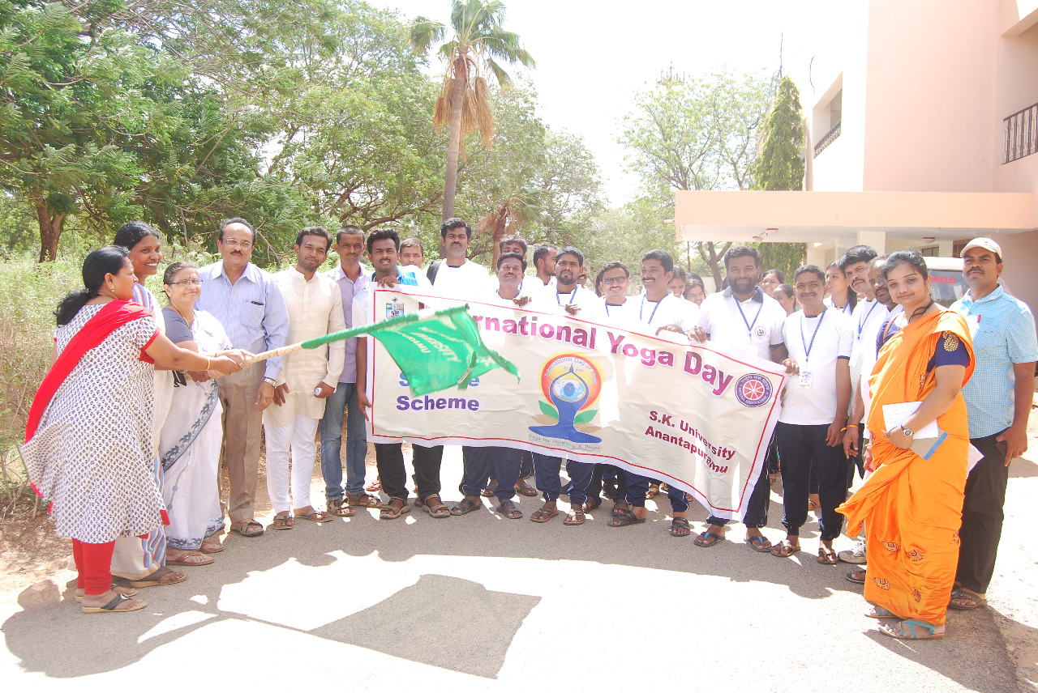

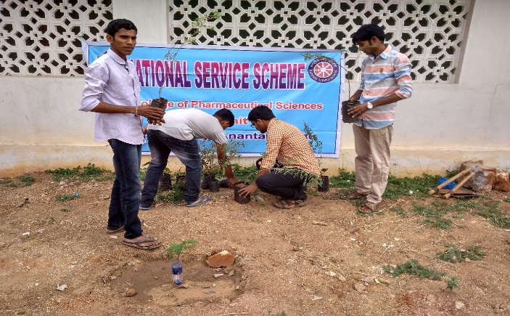
PLANTATION PROGRAMME:
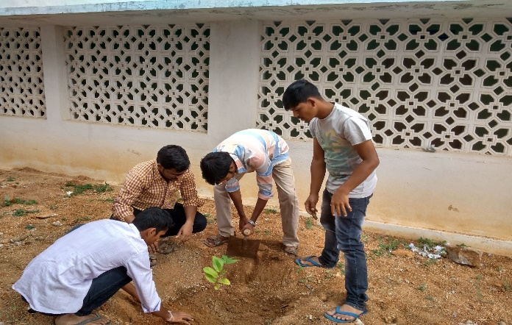
RALLY CONDUCTED ON NATIONAL UNITY DAY CELEBRATIONS
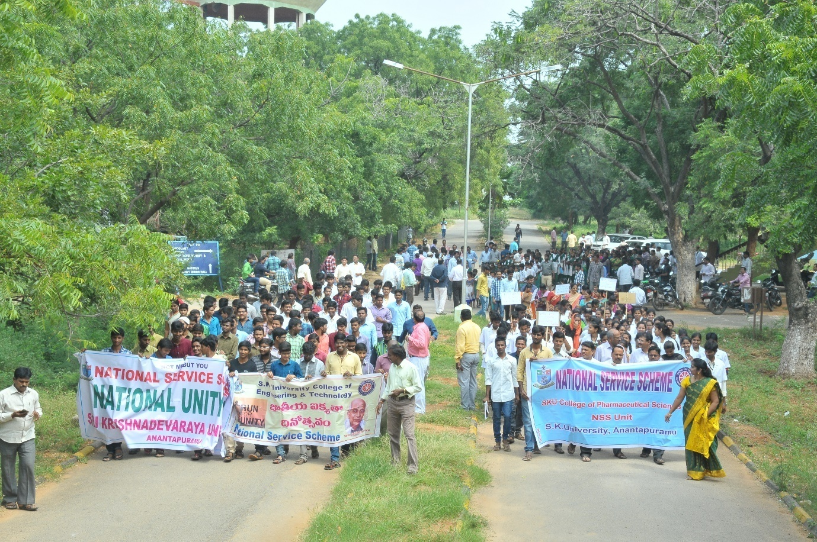
NATIONAL VOTER DAY CELEBRATIONS
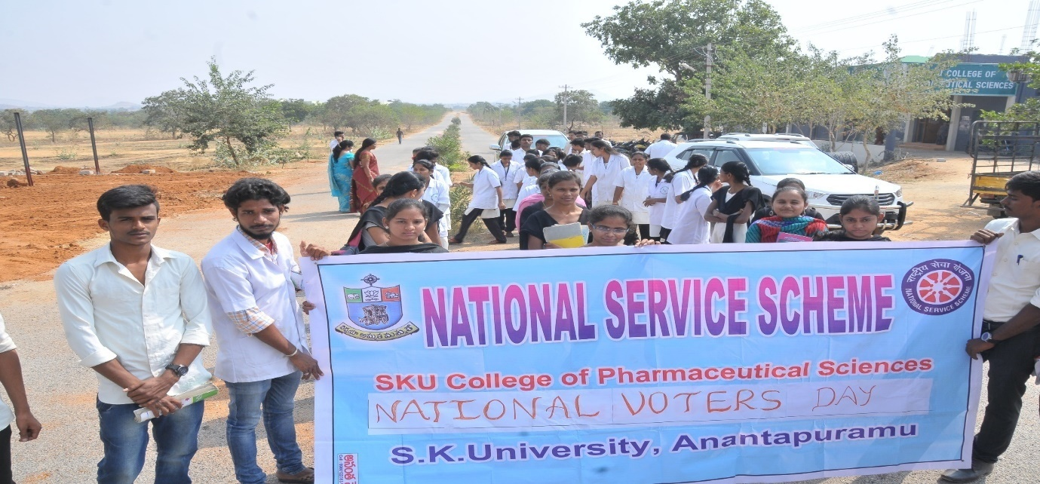
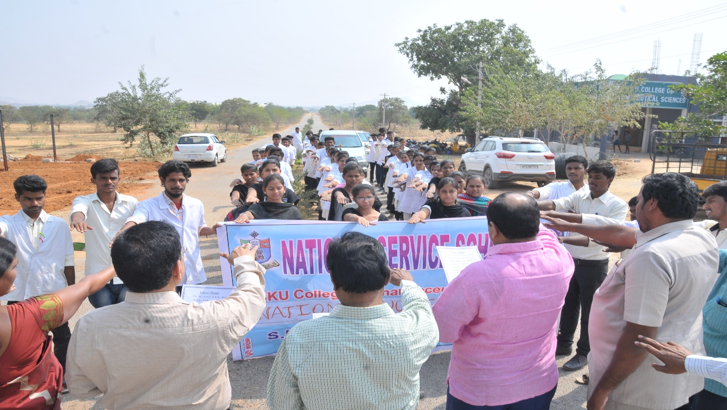

PARTICIPATION OF PROGRAMME OFFICER & VOLUNTEERS IN VARIOUS UNIVERSITY LEVEL, STATE LEVEL AND NATIONAL LEVEL EVENTS:
STATE LEVEL PLANNING, TRAINING AND REVIEW MEETING OF NSS
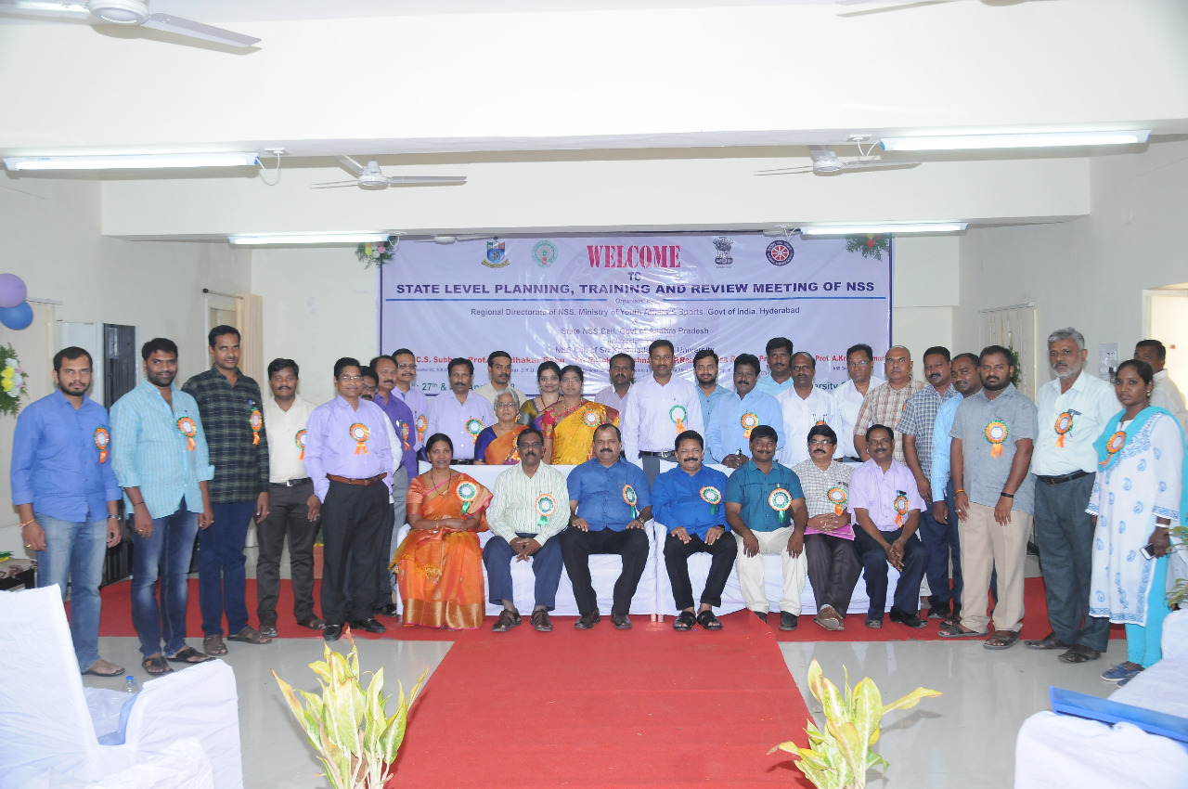
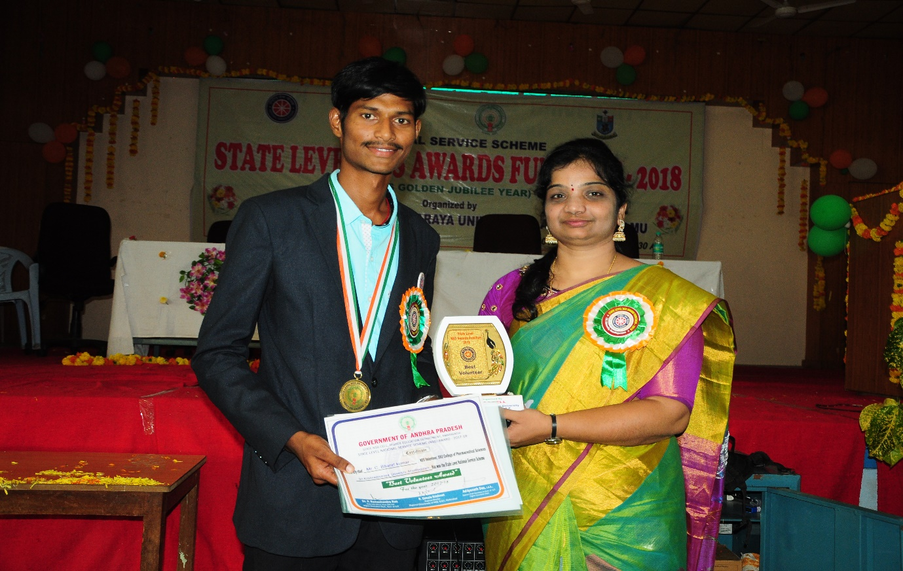
PHOTO CLIPPING WITH C. BHARATH KUMAR, BEST NSS VOLUNTEER STATE AWARD
PRE REPUBLIC DAY CAMP
Two of our volunteers by name C. Bharath Kumar (2016) and Ms. Saritha (2018) participated in Pre RD Camp and brought laurels to our college.
The one in the 2nd place from left in the below picture.
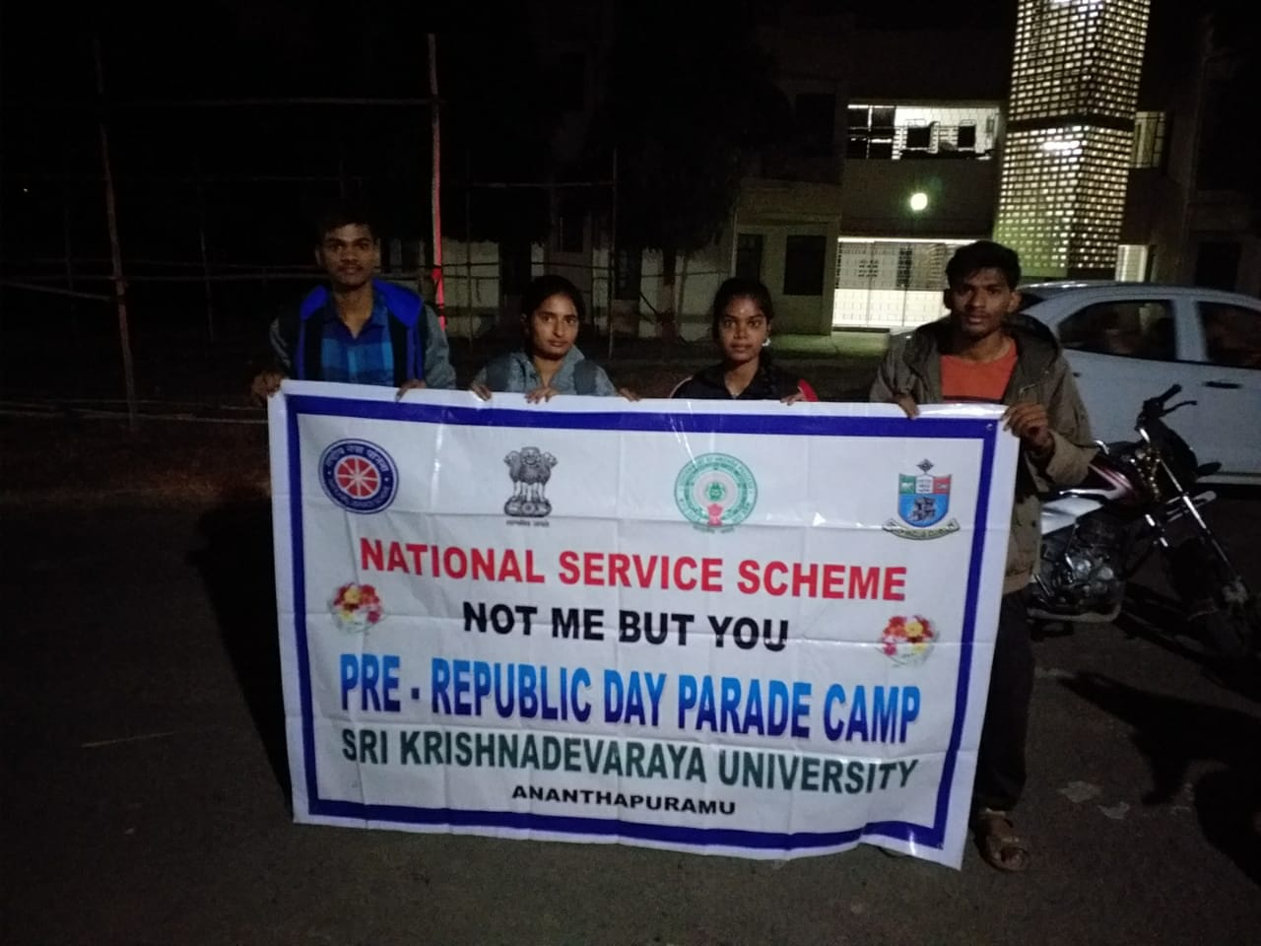
ADVENTURE CAMP:
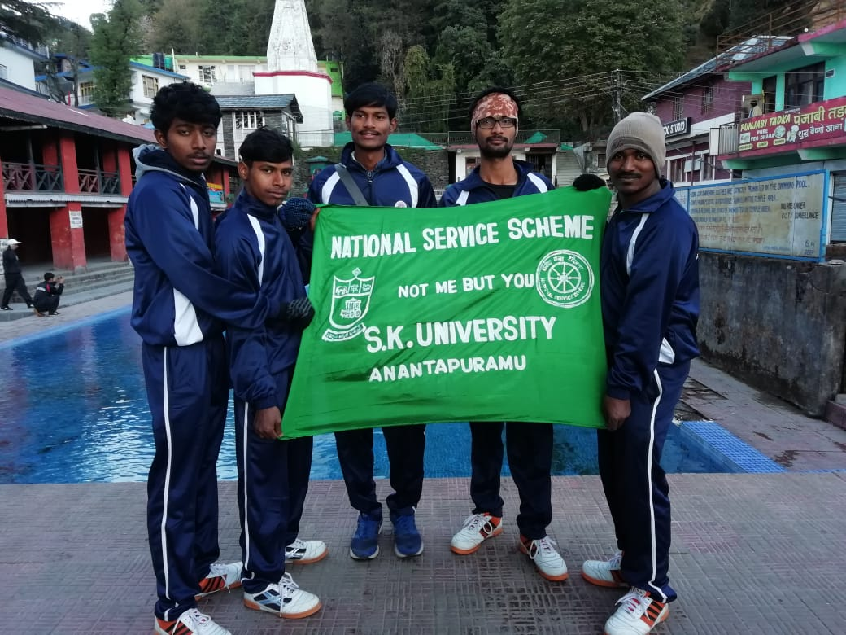
THE ONE IN THE 3RD PLACE FROM RIGHT IS THE VOLUNTEER FROM SKUCOPS NSS UNIT, PARTICIPATED IN ADVENTURE CAMP

PROGRAMME OFFICERS MEETING:: UNIVERSITY LELVEL
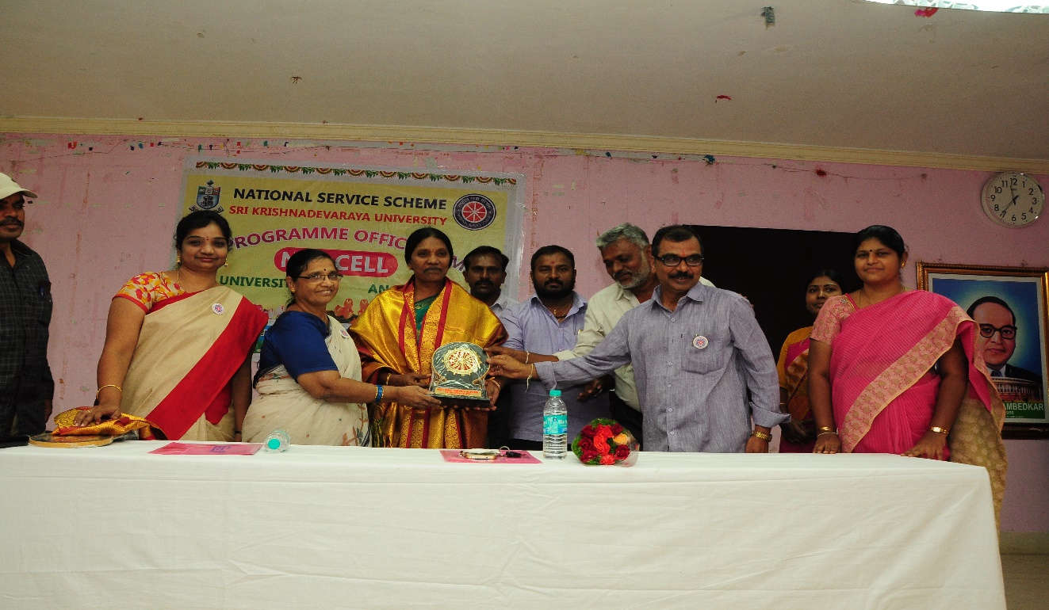

UNIVERSITY LEVEL YOUTH PROGRAMME:
Our Volunteers actively participate in Youth festival every year in University level and has won prizes in many competitions.
Ms Pranathi got 2nd place in essay writing and MS Sravani won 1st prize in patriotic poem.
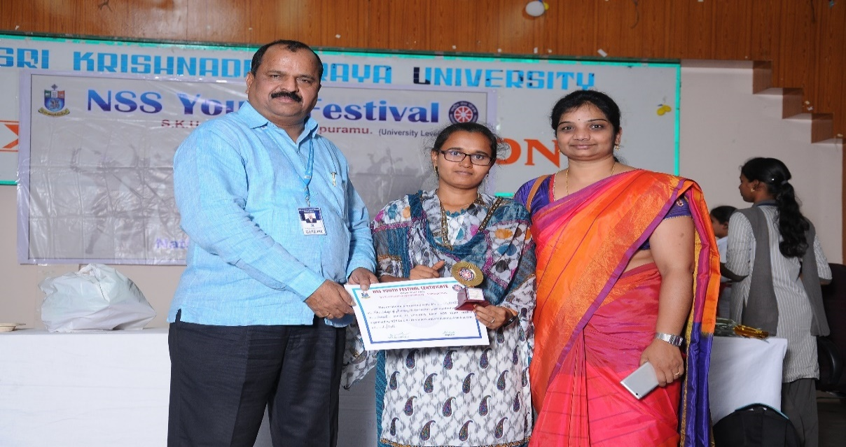
MS. Pranathi of M.Pharmacy got 2nd place in Essay writing in University level.

DISTRICT YOUTH PARLIAMENT TRAINING IN JNTUA:
Appointed as District Nodal Officer for Anantapuramu District to conduct Mock Youth Parliament.
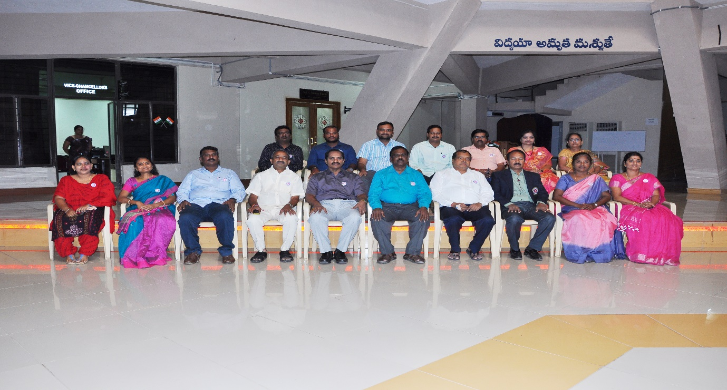
DYP-2018 Nodal officers of Andhra Pradesh – orientation Programme on 20.08.2018
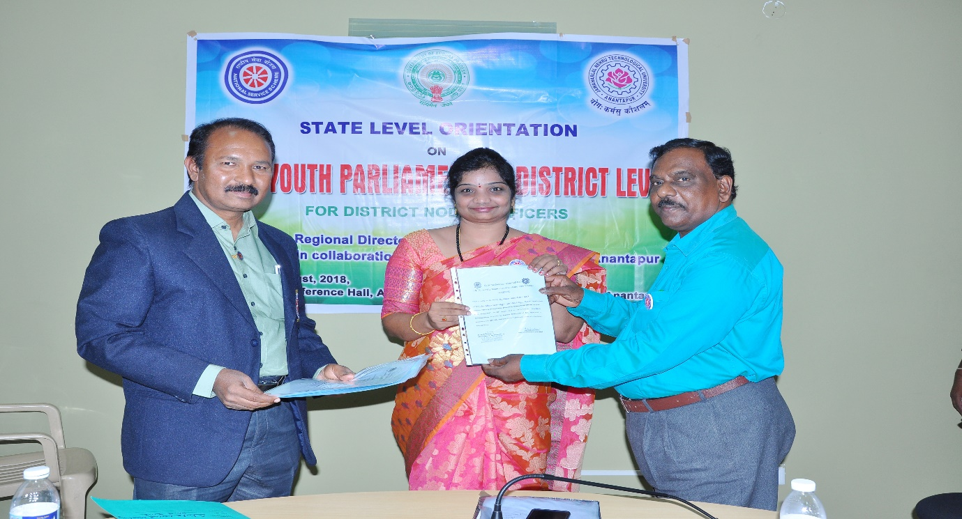

PAPER CLIPPINGS
